*WEB APPLICATION DESIGN WITH METHODS ICONIX PROCESS CASE STUDY:*

*BERSUKARIA WEBSITE*

Wildan Fatahillah Akbar1, Angga Pornama2, Rama Ariya Candra3, Daud Arya Rafa4, Achmad Yusuf Al Ma’ruf5 Anindo Saka Fitri6

1,2,3,4,5,6 Information System Department, UPN “Veteran” Jawa Timur, Surabaya, Indonesia

Received: xx-xx-xxxx; Accepted: xx-xx-xxxx; Published: xx-xx-xxxx

Abstract— The tourism sector is currently an alternative sector that is favored to encourage the Indonesian economy after other sectors, namely the industrial and trade sectors. The opportunity to develop the tourism sector is supported by several facts, including the lifestyle of the people, especially the Indonesian people who now prefer to travel. Bersukaria is one of the MSMEs located in Semarang which is engaged in the tourism sector. However, in one of the business processes and the display design on the website, the bersukaria is still not optimal. Therefore, the revelers carry out development on the website to maximize the business process flow and beautify the appearance of the rejoicing website. Rejoicing website design in this research uses the method ICONIX. The ICONIX method aims to optimize the design of the bersukaria web system. The stages of the Iconix method include making CFDs, functional requirements, GUI design, domain modeling, use cases, robustness diagrams, sequence diagrams, and class diagrams.

Keywords— information systems website; Iconix; Object-Oriented Analysis and Design.

# Introduction

Based on data from the Directorate General of Public Administration, Ministry of Home Affairs published by the Central Statistics Agency. Stating that Indonesia has 17,504 islands in Indonesia spread over 32 provinces (before the division of North Kalimantan and West Sulawesi). The total area of Indonesia is 1.91 million square km, which stretches from Sabang to Merauke. Meanwhile, the population is estimated at 265 million people[1]. With the area it has, Indonesia uses several of its territories to serve as tourism because tourism is the most effective sector to boost Indonesia's foreign exchange. The tourism sector is currently an alternative sector that is favored to encourage the Indonesian economy after other sectors, namely the industrial and trade sectors. The opportunity to develop the tourism sector is supported by several facts, including the lifestyle of the people, especially the Indonesian people who now prefer to travel [2]. In 2020, it was recorded that the total number of foreign tourist visits to Indonesia was 937,747 times from January-July 2021. For foreign tourists, Indonesia is a tourist destination that is always interesting to visit because of its beautiful natural characteristics, the friendliness of its residents to guests who come, and the uniqueness of its local culture.

However, in the effort to develop tourism in Indonesia, there are several problems experienced, one of which is with the Bersukaria. which users in the Bersukaria still use the manual method to register by including Gmail and passwords. In addition, the payment system for Bersukaria still uses a manual payment system, with the user visiting Bersukaria website and choosing packages for tourist destinations and other facilities offered, then at the last stage, the user fills out a google form to make payments. Another problem experienced by bersukaria.com partners is the unsynchronized selection of packages and the total price of payments made by the user. Payment system with virtual account billing method, both local and international banks. International banks still do not support the web for fun, and the packaged web interface is still less attractive and efficient.

In line with this, it is necessary to develop a system for having fun. The development of the system of reveling using the method Iconix process. According to [3], Iconix Processes is an architecture-oriented method. According to [4], the purpose of using the Iconix process is to realize a use case that has been compiled into program code. This method is used in this study because the use of this method is quite efficient without a lot of tabulation but does not ignore brief analysis and design such as Extreme Programming.

This study aims to design a booking system or purchase of tourism entrance tickets, payment systems, and synchronization of package selection with the total price for the user by using a website that has been designed in such a way. This research is expected to help Bersukaria in developing and optimizing their web system , such as making it easier for users to find out which tours they want to visit and the ease of ordering tour packages.

# LITERATURE REVIEW

## Website

Website is a very popular internet resource and can be used to obtain information or make purchases of goods. In line with technological developments, the WWW (World Wide Web) become the need of every company, especially used for media promotion. The website is also the location that will be used to collect web page files. The web document files consist of images, CSS scripts, audio, and so on. With so many files, a website is formed[5]

## User Interface

The user interface is a visual display of a product to bridge between the system and the user. The user interface can be in the form of colors, text, and shapes that have been designed as attractively as possible. The user interface is applied to operating systems, websites, and applications that aim to facilitate user interaction with the products and perform branding of the company[6].

## Iconix Process

According to the MDE (Model-Driven Engineering) paradigm, the software is developed in several stages of the process. The first is to design a model and then refine it from what was originally found at a high level to a lower level of abstraction until the code can be created using a transformation specification [7]. The model that is often used is UML. Booch states that the Unified Modeling Language (UML) is a standard for creating blueprints for software [8]. UML itself is a visual language that can analyze and design object-oriented systems to visualize, build, and document software system artifacts and model business organizations[8]. However, recently this method has been abandoned by the information technology industry sector because the time to get results is considered quite long. Therefore, UML with a use case driven is here to answer these problems. Use case driven, also known as the iconic process (iconic process) is a driven engineering model that uses UML based on use cases, which means that the use case here is used to encourage the development of a software system[4]. Use cases are believed to be a good basis for testing a system.

Iconix process is a process-oriented architecture (architecture-centric). This process focuses on the design of the model as a system architecture which includes a static model which will be in the form of program codes and a dynamic model that describes the behavior of the system. Besides architecture-centric, the Iconix process is also an iterative and stepwise model (iterative incremental). This is because many iterations occur when determining the domain model. When identifying and analyzing use cases, and other iterations that occur as the development life cycle of a system progresses. It has been mentioned that this Iconix has static and dynamic models, later on, the resulting static model will continue to be improved gradually with the help of a dynamic model consisting of use case, robustness analysis, and sequence diagrams. The dynamic model consists of creating a domain model, an updated domain model, and class diagrams. After that, the program code and testing were carried out and ended with making a test plant. The Iconix methods can be seen in Figure 1.

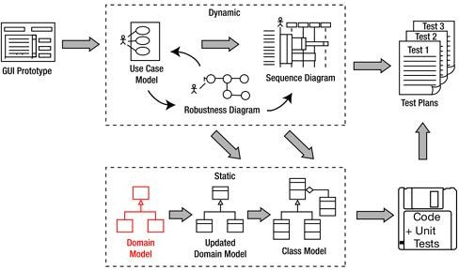

Figure 1. Iconix Process

Different from using case-driven other kinds of Rational Unified Process(RUP) or extreme Programming(XP), Iconix Process the process is not too convoluted as in RUP [9], nor is it too short like in XP. The main goal of Iconix process is how to make it happen use case which has been compiled into a complete program code.[10]

## UML (Unified Model languange)

UML is one of the standard design modding techniques for an object-oriented application or program [11]. In the development process, an interface design will be designed, domain diagrams, use case diagrams, sequence diagrams, robustness diagrams, and class diagrams will be designed [12]. The main purpose of making UML is to provide a ready-to-use model that is easy to understand and understand in general. where the modeling language is free from various programming languages ​​making it easier for program development [13]

# Research Methodology

The methodology used in this research is the Iconix process which includes the following steps:

## Literature Study

Literature study is a method of collecting data through materials in journals, books, and ebooks as a reference for this research.

## Data Collection

This data collection aims to explore the problems faced by partners. Data collection in this study was carried out by interviewing the party from Bersukaria itself and direct observation.

## Analysis of Needs

Requirements analysis is done by analyzing business processes before and after the proposal, determining functional and non-functional requirements, making domain modeling, and requirements review.

## Design System

Designing the system according to the needs is carried out in several steps, namely: Analysis / Premily Design which produces the Robutsness Diagram. Preliminary Design Review which generates updated model domains, Detailed design that produces sequence diagrams and class diagrams.

# Result and Discussion

1. Analysis of Needs
2. *Cross-Functional Diagram in Both Old and New System:* The following is the result of the current cross-functional flow analysis.

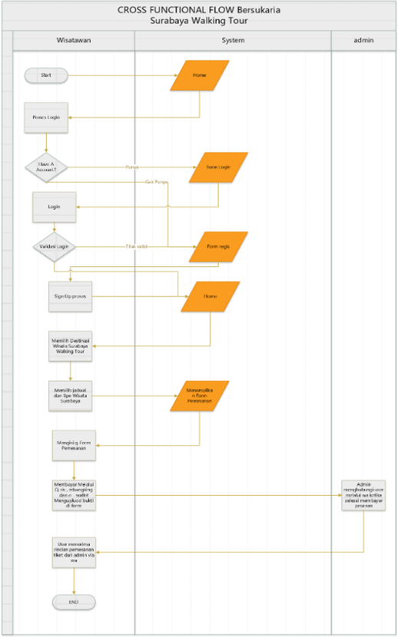

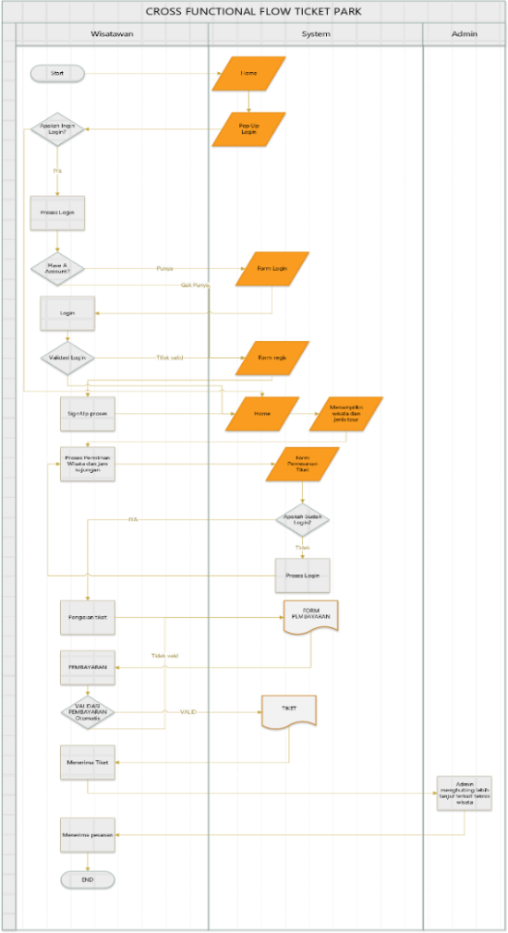

Figure 2. Comparison of old and new system with CFD

Figure 2 describes the comparison of the old CFD with the new CFD. In the new CFD, there are improvements for old CFDs including a login system that can use Gmail and social media accounts. As well as a payment system that can be done via bank transfer with automatic payment checking.

1. *Functional Requirements :* Functional requirements describe what processes can be performed by the system. The functional requirements aim to find out what functions can be performed by the system [14]. From the results of interviews, data obtained that the functional requirements of the Brsukaria website such as, users can log in and register by using Google accounts and social media accounts, users can search for tour packages and can buy tour packages, and users can make payments through various banks.
2. Design System
3. *GUI Design:* The GUI design is a visualization of the display idea of ​​the website to be built so that it can provide an overview of the web appearance that will be generated[15].Figure 3 is the login display design. On the login screen, there is a form for users to enter Username and password and users can also log in via social media accounts.

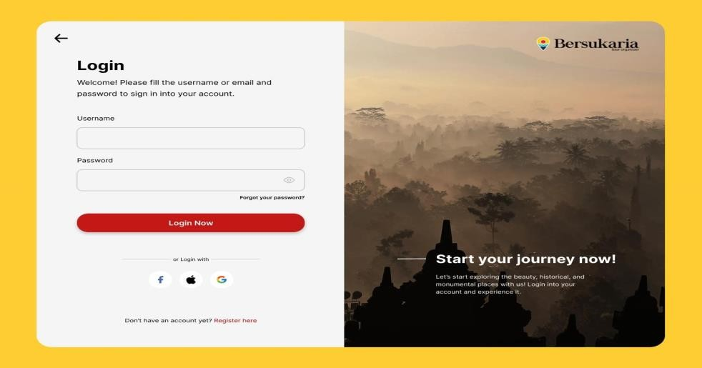

Figure 3. Login display

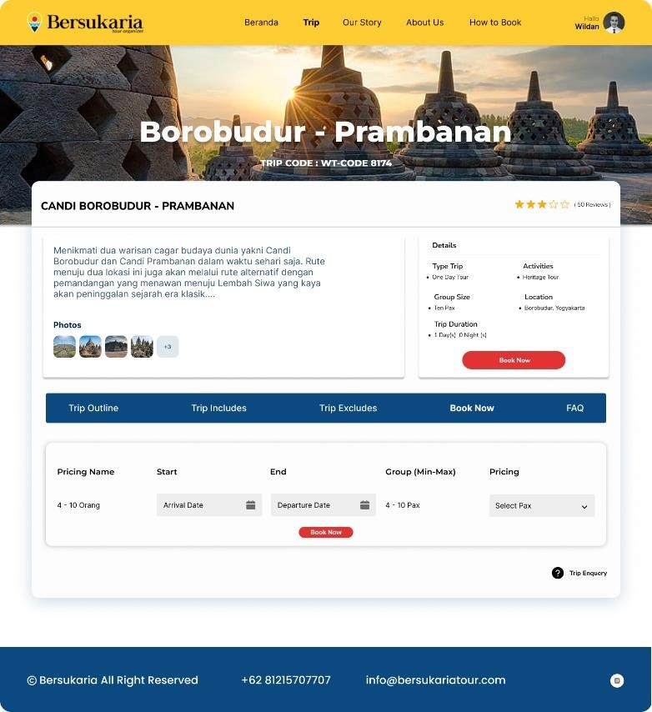

Figure 4. Display of travel bookings

In the picture above is a proposed picture for the login and registrar display where there is information on tourist descriptions, tour details, and an order form.

1. *Domain Modeling:* A domain model is initial modeling to find terms in the form of classes used in a system. The domain model aims to provide the same picture of the problem with the same terms which represent objects and concepts in the real world [16]. In these functional requirements, there are phrases or nouns that can later be used as models in Figure 5.

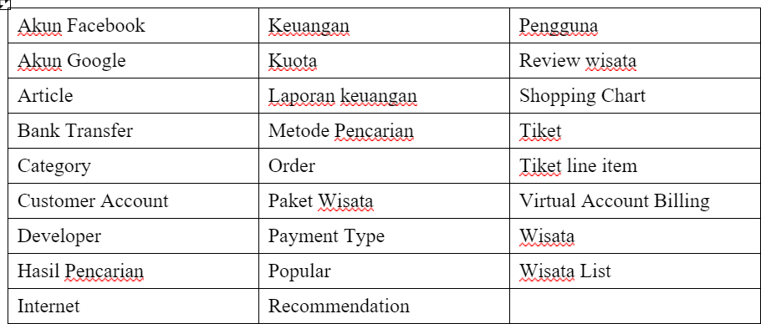

Figure 5. Requirement functional phrases

After determining the functional requirements, the next step is to create a domain model as shown below:

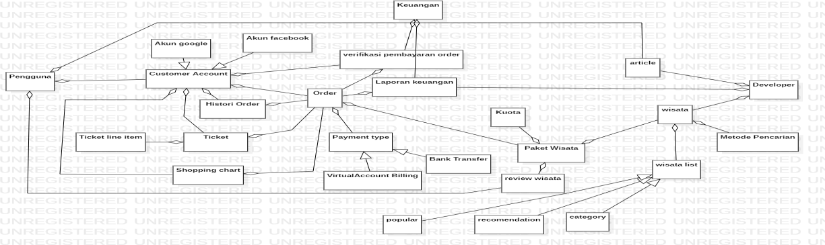

Figure 6. Domain Model Bersukaria Website

Figure 6 is a modeling domain from the results of the analysis of nouns and terms at the needs analysis stage. There are 25 classes including user class, financial class developer class, order class, and ticket class.

1. *Use Case Diagram:* Use case diagrams are diagrams that describe the interaction between actors or users with a system [17].The picture below is a use case from the website that describes the features and functions of each website user. Where users can register, log in, verify payments, make payments, manage master accounts, place orders, review tours, and read articles. Managers can manage tours, manage sales reports, log in and register. Finance admin can manage sales report login, and register.

­­­­­­­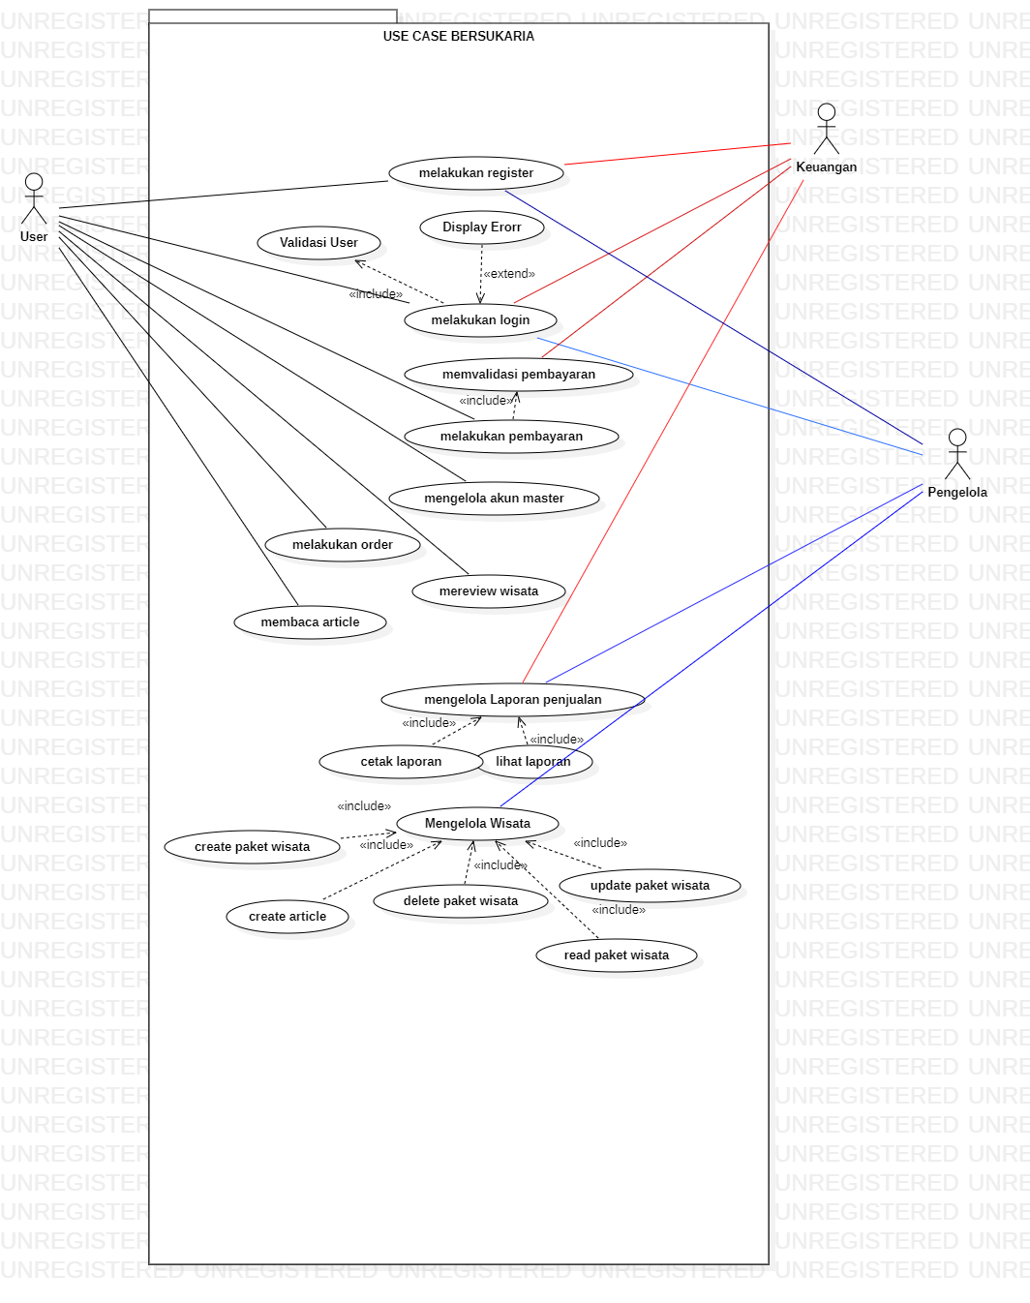

Figure 7. Use case diagram

1. *Robustness Diagram:* A robustness diagram is a diagram that helps to bridge the gap between the actual design analysis and the implementation of program coding [18]The picture below is one of the robustness diagrams that explains the management of orders. Where it starts from the financial admin user and developer who logs into the user to the stage of printing reports or viewing sales reports.

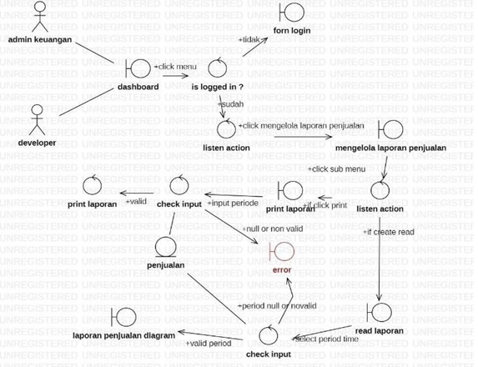

Figure 8. Robustness diagram order management process Bersukaria website

1. *Sequence Diagram:* A sequence diagram is a diagram that serves to display the interactions between objects in a system in detail [19]. The sequence diagram in Figure 8 is a sequence sales management diagram. This sequence starts from the manager/developer user logging in until the managing user chooses to print the report or only view the sales report

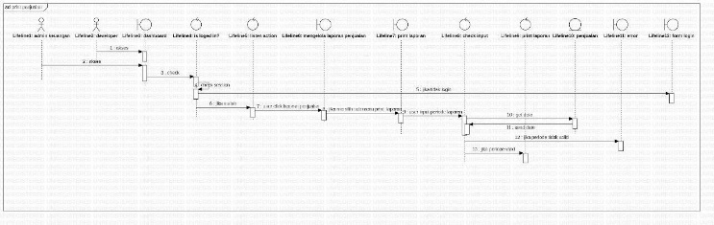

Figure 9. Sequence diagram of sales management process

1. *Class Diagram:* Class diagrams are diagrams that show how the architectural schema of a program is being designed. Class diagrams contain methods and attributes where each class in the class diagram is connected by a line called an association. Class diagram aims to create a logical model of a system that is being built [20] .Figure 10 is a class diagram of a bersukaria website. The class is a development domain model, sequence diagrams, and robustness diagrams. The class diagram in Figure 8 is known for each variable and function for each class.

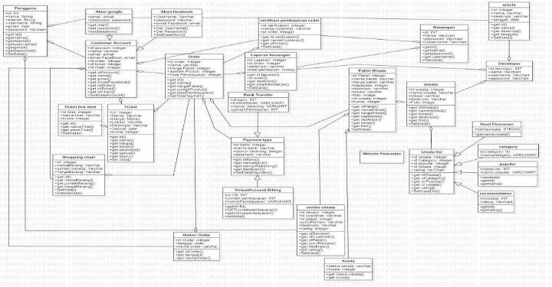

Figure 10. Class diagram Bersukaria website

1. Conclusion

From the results of research, it can be concluded that the process of designing the Bersukaria website is carried out using the Iconix Process method. The old system for logging in or registering included a username and password and a manual payment verification method. The old system was changed to a new system where users can log in and register with social media accounts as well as an automatic payment verification system through virtual account billing.

The Iconix process consists of 4 stages, namely requirements, analysis, preliminary design, detailed design, and implementation. The design in this study resulted in functional requirements, GUI Storyboard, domain modeling, use case diagrams, robustness diagrams, sequence diagrams, and class diagrams that are useful at the system implementation stage in the form of program codes.

The results of the system design using the methodIconix Process can be considered for the system implementation stage in the form of program codes and ends with the testing stage, then for the payment method the researcher suggests cooperating with the company's financial technology and banks that are commonly used by customers so that payments on the website can be carried out easily, then this research is far from perfect so it requires improvements with other methods in future research.

# Acknowlegment

We would like to thank all those who contributed in providing input and suggestions for us. Especially to Mrs. Anindo Saka Fitri S. Kom, M. Kom. As a lecturer in the course of information system design analysis.

# Reference

[1] A. A. Rahma, “Jurnal Nasional Pariwisata Adenisa Aulia Rahma,” 2020.

[2] N. Sbm, “BEBERAPA MASALAH DALAM PENGEMBANGAN SEKTOR PARIWISATA DI INDONESIA,” vol. 7, no. 2, 2020, [Online]. Available: http://ejournal.bsi.ac.id/ejurnal/index.php/jp

[3] Yulianta and P. Mursanto, “PENGEMBANGAN APLIKASI WEB DENGAN ICONIX PROCESS DAN UML STUDI KASUS: SISTEM MANAJEMEN ISI,” *Jurnal Sistem Informasi MTI-UI*, vol. 4, pp. 115–121, 2008.

[4] D. Rosenberg, *Inside the ICONIX Process*. Addison-Wesley, 2001.

[5] I. Rosyadi and A. Sari, “SISTEM INFORMASIPADA ‘MAYA’ WEDDING ORGANIZERBERBASIS WEBSITE,” *SURYA INFORMATIKA* , vol. 5, pp. 24–33, 2018.

[6] M. N. el Ghiffary, T. D. Susanto, and A. Herdiyanti, “Analisis Komponen Desain Layout, Warna, dan Kontrol Pada Antarmuka Pengguna Aplikasi Mobile Berdasarkan Kemudahan Penggunaan (Studi Kasus: Aplikasi Olride),” *JURNAL TEKNIK ITS*, vol. 7, pp. 143–148, 2018.

[7] Markus Völter *et al.*, *Model-Driven Software Development: Technology, Engineering, Management*. Wiley Software Patterns Series, 2006.

[8] Grady Booch, James Rumbaugh, and Ivar Jacobson, *Unified Modeling Language User Guide, The (2nd Edition)*. Addison-Wesley Object Technology Series, 2005.

[9] Doug Rosenberg and Kendall Scott, *Applying Use Case Driven Object Modeling with UML : An Annotated e-Commerce Example*. ADDISON-WESLEY, 2001.

[10] A. F. Istifani and Sholiq, “Rancang Bangun Aplikasi Koperasi Simpan Pinjam dengan Metode Viewpoint Oriented Requirement Definition,” *Jurnal sisfo*, vol. 7, pp. 165–180, 2018.

[11] O. Somantri, D. Surono Wibowo, and M. Husni Faulin, “PGawean: Aplikasi Mobile Lowongan Pekerjaan Kota Tegal Berbasis Unified Modeling Language (UML),” 2018.

[12] M. T. Prihandoyo, “Unified Modeling Language (UML) Model Untuk Pengembangan Sistem Informasi Akademik Berbasis Web,” *Jurnal Informatika: Jurnal Pengembangan IT (JPIT)*, vol. 3, pp. 126–129, Jan. 2018.

[13] D. Etika Profesi and henderi, “ANALISIS DAN PERANCANGAN SISTEM INFORMASI KEPEGAWAIAN MENGGUNAKAN UNIFIED MODELING LANGUAGE (UML) Analysis And Design Of Employee Information System Use Unified Modeling Language (UML),” *JURNALSISTEM INFORMASI DAN TEKNOLOGI INFORMASI*, vol. x, No.x, no. 1, pp. 22–33, 2018.

[14] L. Setiyani and E. Tjandra, “ANALISIS KEBUTUHAN FUNGSIONAL APLIKASI PENANGANAN KELUHAN MAHASISWA STUDI KASUS:STMIK ROSMA KARAWANG,” *Jurnal Informasi Pendidikan Dan Teknologi Informasi*, vol. 2, 2021, [Online]. Available: http://ejournal.stkip-mmb.ac.id/index.php/JIPTI

[15] W. Buana and B. Nurina Sari, “Analisis User Interface Meningkatkan Pengalaman Pengguna Menggunakan Usability Testing pada Aplikasi Android Course,” *Journal of Computer and Information Technology*, vol. 5, no. 2, pp. 91–97, 2022, [Online]. Available: http://e-journal.unipma.ac.id/index.php/doubleclick

[16] L. N. Safitri, S. A. Wicaksono, and M. C. Saputra, “Analisis dan Perancangan Sistem Informasi Manajemen Pusat Laktasi : Lactashare,” *Jurnal Pengembangan Teknologi Informasi dan Ilmu Komputer*, vol. 2, no. 6, pp. 2286–2294, 2018, [Online]. Available: http://j-ptiik.ub.ac.id

[17] F.- Sonata, “Pemanfaatan UML (Unified Modeling Language) Dalam Perancangan Sistem Informasi E-Commerce Jenis Customer-To-Customer,” *Jurnal Komunika : Jurnal Komunikasi, Media dan Informatika*, vol. 8, no. 1, p. 22, Jun. 2019, doi: 10.31504/komunika.v8i1.1832.

[18] D. Indra Gunawan Hutasuhut, U. Verawardina, O. Alfina, E. Ginting, and H. Zaharani, “E-Learning Pembelajaran Ilustrasi Menggunakan Metode Iconix Process,” *Jurnal Sains Komputer & Informatika (J-SAKTI*, vol. 5, no. 1, pp. 29–38, 2021.

[19] Suendri, “Implementasi Diagram UML (Unified Modelling Language) Pada Perancangan Sistem Informasi Remunerasi Dosen Dengan Database Oracle (Studi Kasus: UIN Sumatera Utara Medan),” *ALGORITMA: Jurnal Ilmu Komputer dan Informatika*, p. 1, 2018, [Online]. Available: http://www.omg.org

[20] W. Aliman, “Perancangan Perangkat Lunak untuk Menggambar Diagram Berbasis Android,” *Syntax Literate ; Jurnal Ilmiah Indonesia*, vol. 6, no. 6, p. 3091, Jun. 2021, doi: 10.36418/syntax-literate.v6i6.1404.

[https://licensebuttons.net/l/by-sa/3.0/88x31.png](http://creativecommons.org/licenses/by-sa/4.0/)This is an open access article under the [CC–BY-SA](http://creativecommons.org/licenses/by-sa/4.0/) license.